11th September 2023
Parent survey responses
Dear Parents and Carers,
Thank you for your recent responses to our annual parent/carer survey – the results are always so interesting and helpful in our strive to continually improve. This year we have been really pleased to see a significant increase in positive survey results compared to last year. Very pleasingly, 100% of respondents agreed or strongly agreed with the statement that school makes me aware about my child’s learning. This is an area that as a school we have focussed on this year so it is fantastic to see that this has been useful for families. Similarly, 98% of families responded positively to the school having high expectations of our children. Both these statements are a delight to hear and are both areas that staff have focussed on this year.
Other survey responses were also positive: having high expectations of children; dealing with concerns promptly; sharing what children are learning during the year; ensuring pupils are well behaved; teaching a good range of subjects; supporting wider development of children.
We are particularly impressed with the responses to ‘The school make sure pupils are well behaved’. This was one of our school improvement priorities last year and the survey has shown an increase of 20% in positive responses compared to last year. A recent pupil survey responses also reflected these improvements with 100% of the pupils surveyed selecting that they agreed or strongly agreed that behaviour in lesson is good. The final question within the survey was for your written comments. Similarly, these were also very positive, with parents/carers noting our ‘fabulous staff’, ‘feeling supported and fully informed’, and our ‘environment is safe and learning is great’. Children’s progress was also celebrated, with comments that ‘my child’s achievements this year have been amazing’, ‘school have been amazing supporting my child’s wellbeing’ and ‘my child is doing really well’. Knowing the care and dedication of our staff like I do, I was certainly not surprised to read many, many wonderful comments about adults in school which will be shared.
Your responses will give us aspects to consider moving forward for school improvement. There was a variation of responses to the question about support for children with SEND. We will endeavour to increase our communication linked to SEND learners this academic year to ensure that families have a good understanding of all the fantastic strategies and support that school provides for our SEND pupils. Furthermore, at times, a few respondents replied that they ‘didn’t know’ about some statements. If you would like more information about anything at West Vale Academy, please do not hesitate to contact us or make an appointment via the school office, visit our website or speak to staff at pick up– we are always happy to help.
As ever, we really do appreciate and acknowledge the honour of being a leader at West Vale Academy – our children and community are second to none. Thank you for all your continued support in making West Vale as positive as it is.
With my very best wishes,
Miss Horsfall, Mrs Akroyd and Miss Vincent
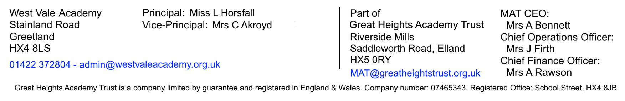
Senior Leadership team

