Induction Booklet for Reception Parents

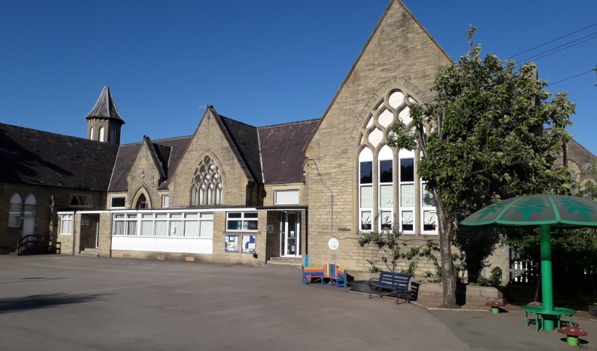

Welcome
Message from the Principal

I would like to warmly welcome you to West Vale Academy. I am extremely proud to be the school’s Principal and I am keen to drive the academy forwards on its exciting journey of improvement and excellence.
We believe that children deserve the best possible chances in life and that they learn best when there are strong links between home and school. Everything we do at West Vale helps us to deliver our school motto of ‘Care, share, discover and learn’. Success to us at West Vale means both academic and personal progress. It also means promoting an inclusive school culture, nurturing staff-pupil relationships and promoting the values that underpin our school – values of kindness, resilience, honesty, endeavour, curiosity and courage. The academy’s ethos is centred around positive behaviour management strategies with staff applying a fair and consistent approach. We endeavour to provide a calm and stimulating environment where good behaviour and mutual respect is modelled by everyone and where everyone is valued. We aim to ensure that our children leave West Vale fully prepared for Secondary school and beyond with the solid foundation of skills, knowledge and values they will need to become happy and responsible future citizens of the world!
We pride ourselves on working in partnership with parents and families as we know that a child’s primary school years represent a very special journey – we’re here throughout to celebrate their successes, solve problems and provide high quality education.
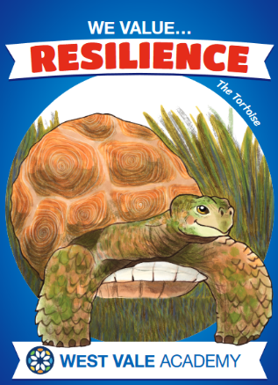
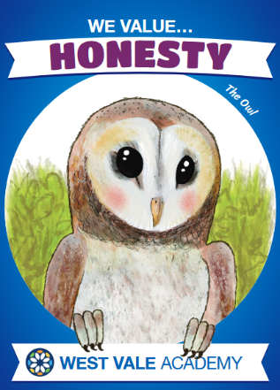
Please do not hesitate to contact our school office for any additional information you require. Our school Facebook page provides a really good reflection of day to day school life and is added to frequently so follow us on West Vale Academy to see our school values and vision in action!

School Times

The day starts at 8.50am. Any late arrivals need to come into school through the main entrance by the office. At home time, the school gates are opened at 3.15pm and the children will be brought to the external doors at 3.20pm. We ask that all parents wait in the main playground near the children’s exits. We call the children one at a time to ensure they go home safely.

Absences

Please notify school if your child is ill, either by telephone, in person or by email before 9am in the morning:
01422 372804
admin@westvale.calderdale.sch.uk

Holidays

Dates are published on the school newsletter early in the academic year and are also on the website. The Principal may not grant any leave of absence during term time unless there are exceptional circumstances. For full details of our attendance policy please visit our website.

Learning in Reception

During the Reception year the children will be learning through structured adult-led activities and play. The play within the classroom and outdoor learning environment is both challenging and fun and helps children develop a positive attitude towards learning for the rest of their school life.

The children will have daily Phonics and Maths focus sessions which build over time in length and independence as we work towards Year One. Phonics teaching is currently taught through using the Little Wandle Letters and Sounds programme.

The children will engage in a range of different activities related to broad topics. Some of these activities will take place in large groups, some in smaller groups and some individually. There will be a mix of adult led and child-initiated activities.

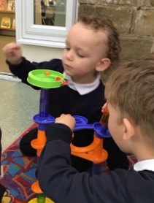
There are seven areas of learning that shape the Early Years Curriculum. All areas of learning and development are important and inter-connected. The three prime areas are particularly crucial for igniting children’s curiosity and enthusiasm for learning, and for building their capacity to learn, form relationships and thrive. The three prime areas are:
• Communication and Language
• Physical Development
• Personal, Social and Emotional Development.
There are four specific areas through which the three
prime areas are strengthened and applied. The specific
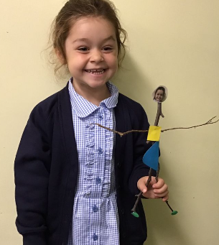
areas are:
• Literacy
• Mathematics
• Understanding the World
• Expressive Arts and Design

At the end of the year we will provide you with a written
report based around the Foundation Stage Profile. The
Foundation Stage Profile is an assessment that is completed
for all reception children at the end of their reception year.
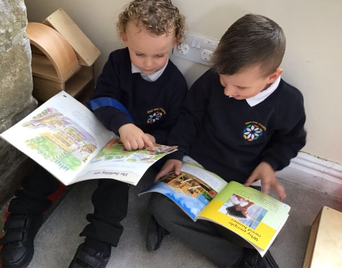
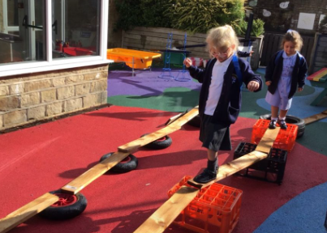
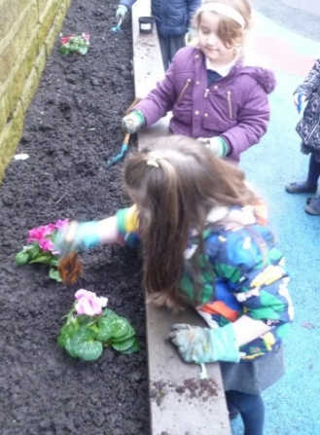

A Typical School Day

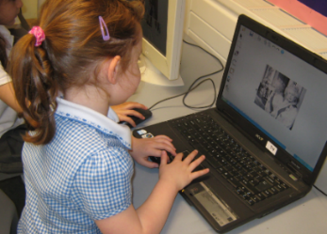
8.50 School begins. Morning work task.

9.00 Register

9.05 Phonics Input. This is a whole class carpet session.

9.30 Child Initiated Learning
Children have the opportunity to choose what and where they wish to learn from a wide range of carefully planned indoor and outdoor provision. Adults support children to learn by interacting, challenging and supporting them in this provision.

10.45 Milk and Snack

11.00 English/Understanding of the World.
This is a whole class carpet session.

11.45 Dinner
Children eat their lunch together in the school dining room and then have the
opportunity to play outside.

12.45 Afternoon Register and Maths Input. This is a whole class carpet session.

1:00 Child Initiated Learning

2.20 Finger Gym and Handwriting
The children complete dances with their hand and fingers to different songs which
helps develop their fine motor control.

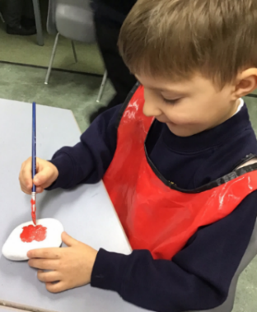
2.30 Story time

3.20 Home Time
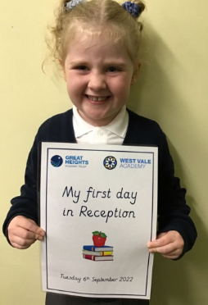
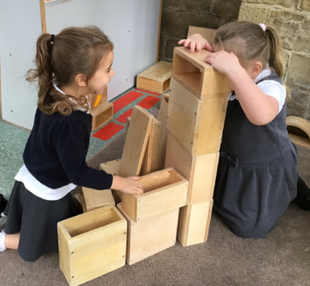
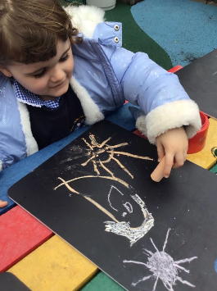

Physical Development

The children will have one P.E. session per week. P.E. Kit includes:
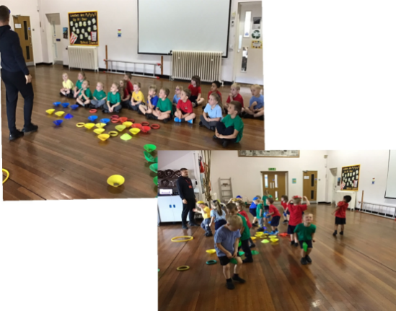
- Navy Blue shorts
- A t-shirt in your child’s allocated
team colour.
- Trainers
- Black/blue logging bottoms
and a plain warm jumper
for outdoor PE.

Please ensure that all items are named – it helps enormously!
Please be aware that jewellery is not allowed to be worn in school and cannot be worn during P.E. lessons under any circumstances.

Library Time

Reading a wide range of books to your child on a regular basis is so important, helping to develop language and imagination, understand the purpose for reading and most of all, develop a lifelong love of books. To support you in this, we hold a weekly library session in Reception where your child will spend time choosing a book to bring home. Please ensure this is kept in your child’s book bag so it can be exchanged each week for a new one.

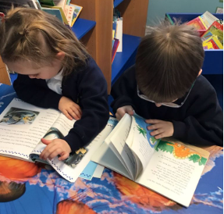

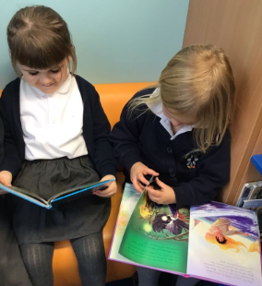

Parent Participation

At West Vale Academy, we view your child’s education as a partnership between home and school. In order for your child to reach their full potential it is important that we work as a team. We hold regular whole school events which the children really enjoy and we encourage families to be involved; highlights include the Halloween disco and Christmas Fayre. We release a calendar of all our parent events to allow parents advance notice.

Seesaw

At West Vale Academy we use an app called
Seesaw throughout school as an interactive
learning platform. It is a simple way for
teachers and pupils to record and share what
is happening in the classroom. Seesaw gives pupils a place to document their learning, be creative and learn how to use technology. Each child gets their own online journal which follows them up through school. When there are new Seesaw posts, families can be notified via app notification, email or SMS. Parents are only notified about their own child’s work, and all data is safe and secure.

Many parents ask what we want children to do before they come to school. Here are the things which help to make the school day and routines simpler:
Preparation

- I can use the toilet all by myself
- I can zip up and fasten my coat
- I can dress myself and change for PE
- I can wash and dry my hands & face
- I can use a knife & fork
- I can put on my own shoes and fasten them

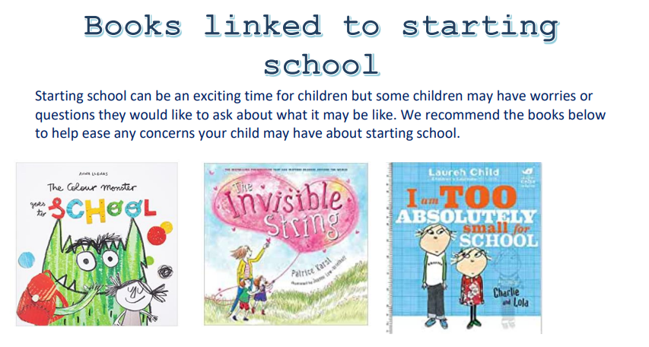

School Dinners

Dinners are freshly cooked in our own kitchens. We offer choices each day, including a vegetarian option and the menus rotate over a three week cycle. Menus are changed seasonally and information is sent home for you and your child to choose their lunch and place their order on-line via our website. If your child has any specific dietary requirements please let us know so that we can tailor a menu to suit your needs. All pupils in reception, year one and year two in state-funded schools in England are eligible for free school meals (FSMs), this includes academies. More information regarding school meals payments will be sent to you when your child moves to Year Three
.

Water Bottles

Children are encouraged to bring a bottle of water to school to
keep well hydrated during the school day. To promote a healthy
lifestyle this must be water and not juice.
Milk

Milk is available to all children in Reception and Key Stage One. For all our under 5's this is free. West Vale will automatically register your child to receive school milk each day. When children reach their fifth birthday they can continue to receive milk as part of the CoolMilk scheme for approximately £15 per term. Please visit the following site for more information: https://www.coolmilk.com

Snacks

At West Vale Academy, we strive to promote a healthy lifestyle. Children are offered fresh or dried fruit and vegetables, provided by a government scheme to encourage children to eat five a day. This includes a different choice each day.

School Uniform

- Plain grey trousers or skirt.
- White polo shirt with school logo or plain.
- Navy Sweatshirt with school logo or plain.
- Plain socks or tights
- Black school-type shoes
- In warm weather blue and white check dresses
and grey shorts can be worn.

Children should not come to school wearing fashion trainers, jeans, tracksuits, sportswear or beachwear. Please ensure all items of uniform are clearly labelled with your child’s name.

Family Circumstances

If there is any change in family circumstance, please let us know. Changes can affect a child’s behaviour and well-being in many ways and we need to ensure we can support your child at all times-but to do this we need to know if anything has changed in the home, This may be news of a pet that is ill, grandparents who are away on holiday, a parent/carer who is working away, a family illness, a separation etc.
The more we know the better we can support your child.

Getting In Touch

Stainland Road
Greetland HX4 8LS
01422 372804
admin@westvaleacademy.org.uk

