Pupil premium strategy statement

This statement details our school’s use of pupil premium (and recovery premium for the 2022 to 2023 academic year) funding to help improve the attainment of our disadvantaged pupils.

It outlines our pupil premium strategy, how we intend to spend the funding in this academic year and the effect that last year’s spending of pupil premium had within our school.

School overview
Detail | Data
School name | West Vale Academy
Number of pupils in school | 123
Proportion (%) of pupil premium eligible pupils | 47 (38%)
Academic year/years that our current pupil premium strategy plan covers (3 year plans are recommended) | 2022-25
Date this statement was published | September 2022
Date on which it will be reviewed | January 2023
Statement authorised by | Amanda Bennett (CEO)
Pupil premium lead | C Akroyd
Governor / Trustee lead | Debbie Shutter
Funding overview
Detail | Amount
Pupil premium funding allocation this academic year | £79,219
Recovery premium funding allocation this academic year | £8,700
Pupil premium funding carried forward from previous years (enter £0 if not applicable) | £0
Total budget for this academic year  If your school is an academy in a trust that pools this funding, state the amount available to your school this academic year | £87,919

Part A: Pupil premium strategy plan

Statement of intent
At West Vale Academy, we believe that all children should reach their full potential, whatever their background or circumstances. We want all children to leave the school with the essential knowledge and skills that they need for future success encompassing the core values of care, share, discover and learn.
Our Pupil Premium strategy is informed by high quality research to ensure we provide the best possible route to improve the educational outcomes of children. This is done through a tiered model with focuses on
- high quality teaching
- targeted academic support
- wider strategies

We firmly believe that Quality First Teaching is the most important tool schools have to improve outcomes for disadvantaged pupils. With this in mind, our Pupil Premium Strategy will be rooted strongly in providing highly skilled staff to provide quality first teaching and learning. This will be matched with an equal emphasis on providing wellbeing support to ensure pupils are emotionally ready to learn. We aim to work with parents to form a partnership in ensuring that our disadvantaged children are offered wider opportunities and experiences through our curriculum design and to ensure parents are as fully involved as possible in encouraging and supporting their children to progress. Raising attendance for this group of children is a key factor in this.

Challenges

This details the key challenges to achievement that we have identified among our disadvantaged pupils.
Challenge number | Detail of challenge
1 | In writing, in some year groups (Y2,Y3,Y4 and Y6) non pupil premium are outperforming pupil premium children. Particular year groups of concern being Y2 ( 25% pupil premium at expected/greater depth vs 70% of non-pupil premium children) and Y3 (57% of PP children at expected or greater depth vs 85% of non PP)
2 | In reading, in all year groups non-pupil premium pupils are outperforming pupil premium children. Particular year groups of concern being current Y2 ( 40% pupil premium at expected/greater depth vs 89% of non-pupil premium children), current Y3 (57% vs 75% of non PP).
3 | In maths, non-pupil premium pupils in all year groups are outperforming pupil premium children. Particular year groups of concern being Y2 ( 40% pupil premium at expected/greater depth vs 66% of non-pupil premium children), Y3 (57% vs 75% of non PP), current Y4 (40% of PP vs 66% non PP) and Y5 (63% PP vs 85% non PP)
4 | The indices of deprivation show that in the Greetland and Stainland ward 11.3% of children aged 0-15 are from income deprived families. As a school we have found through staff observations that financial barriers for parents affect their ability to provide wider experiences for their children.
5 | 64% of behaviour incidents between 2021- 2022 were logged as ‘emotional’ and were linked to pupil’s difficulties around self-regulation (with over 70% being linked to PP children). PP pupils requiring social and emotional learning so that they can self-regulate and maintain presence and focus in lessons
6 | To increase parental engagement, particularly the percentage of pupil premium parents accessing seesaw. Currently 47 % of pupil premium children’s parents do not engage regularly on seesaw
7 | In the academic year 2021-2022 the attendance of pupil premium children was 91.7% (of which 27.7% were persistent absentees vs 94.2%(of which 11.9% were persistent absentees) for non-pupil premium. We are keen to improve the attendance of PP children and reduce the persistent absentees as we feel this will also support challenge numbers 1,2 and 3.

Intended outcomes
This explains the outcomes we are aiming for by the end of our current strategy plan, and how we will measure whether they have been achieved.
Intended outcome | Success criteria
Challenge 1,2,3  Pupil Premium children’s attainment progress and attainment in reading, phonics, writing and maths is equal to or greater the national data for pupil premium children.  Where in school data evidences there is a gap between pupil premium and non-pupil premium peers this will be reduced (see above data). | Pupil Premium pupils achieve at or above national average progress scores in KS2.  Attainment data shows Pupil Premium children are achieving at or above the national expectations in EYFS, KS1 and KS2.  Data shows that the gap (where identified) has been reduced between pupil premium and non-pupil premium pupils by the end of the strategy plan.
Challenge 4  All children will have a wider range of opportunities and experiences to enable them to access the curriculum with their non-pupil premium peers. | Data will evidence the impact of the opportunities and experiences provided across the curriculum, including participation in clubs and events.
Challenge 5  Children will be emotionally ready to learn and fully engaged in the curriculum. | Children will be able to manage, regulate and talk about their feelings appropriately with other children and staff. Children will be emotionally ready to learn. Less learning time will be impacted by issues arising from social emotional mental health.
Challenge 6  To increase parental engagement for PP children. | Seesaw tracking evidences parental engagement.  Attendance at school events and workshops show an increased level of parental engagement.
Challenge 7  Improve the attendance of PP children to 95% + and reduce the number of persistent absentees for PP children (see above data) | Increased levels of attendance for PP children. Reduced levels of PP persistent absentees.  Children, parents and staff surveys evidence positive attitudes to learning and behaviour. End of year data reflects good or better for progress vulnerable/pupil premium children.

Activity in this academic year
This details how we intend to spend our pupil premium (and recovery premium funding) this academic year to address the challenges listed above.

Teaching
Budgeted cost: £ 27,040.81
Activity | Evidence that supports this approach | Challenge number(s) addressed
Training and coaching on curriculum development and behaviour strategies | Evidence suggests that professional development opportunities that are carefully designed and have a strong focus on pupil outcomes have a significant impact  on student achievement.  https://educationendowmentfoundation.org.uk/education-evidence/guidance-reports/effective-professional-development | 1,2,3,
Dedicated management time for robust analysis of PP data. Allowing for timely intervention to identify and address the causes of limited progress for PP learners in key subjects in key year groups. Time allocated to follow up on trends in data with lesson observations, book scrutinies and pupil interviews to identify next steps to allow for rapid progress. | The best available evidence indicates that great teaching is the most important lever schools have to improve pupil attainment. Ensuring every teacher is supported in delivering high-quality teaching is essential to achieving the best outcomes for all pupils, particularly the most disadvantaged among them.  https://educationendowmentfoundation.org.uk/thetiered-model/1-high-quality-teaching/  The evidence supports that data analysis is important to identify areas of concerns within the data and pin point what element needs support/ addressing.  https://assets.website-files.com/5ee28729f7b4a5fa99bef2b3/5ee9f507021911ae35ac6c4d_EBE_GTT_EVIDENCE%20REVIEW_DIGITAL.pdf?utm_referrer=https%3A%2F%2Fwww.greatteaching.com%2F | 1,2,3
Dedicated management time for analysis and development of the maths curriculum linked to the SDP.  Staff meetings planned to deliver guidance on using manipulatives and representations to support learning. Training for all staff to ensure a consistent approach. | The evidence supports that it is important to use assessment to build on pupils’ existing knowledge and understanding, use of manipulatives and representations and teach pupils strategies for solving problems. It is important to have a staff member with appropriate time to identify trends in data and deliver actions to address these.  https://d2tic4wvo1iusb.cloudfront.net/eef-guidance-reports/maths-ks-2-3/KS2_KS3_Maths_Guidance_2017.pdf?v=1635355220 | 3

Targeted academic support
Budgeted cost: £ 39,178.19
Activity | Evidence that supports this approach | Challenge number(s) addressed
Use of summative assessment tools to ensure accurate data to assess pupil progress for PP and non PP groups. Due to the formation of a new foundation curriculum, staff will be required to create an assessment framework that matches the curriculum to accurately reflect pupil progress. | Evidence shows that assessment should be used not only to track pupils’ learning but also to provide teachers with information about what pupils do and do not know. This should inform the planning of future lessons and the focus of targeted support. An accurate assessment framework will also support staff is delivering clear and effective feedback that identifies next steps to accelerate progress.  https://educationendowmentfoundation.org.uk/guidance-for-teachers/assessment-feedback | 1,2,3,4,
Targeted 1:1 and small group interventions delivered by teacher and TAs | Small group tuition is defined as one teacher, trained teaching assistant or tutor working with two to five pupils together in a group. This arrangement enables the teaching to focus exclusively on a small number of  learners, usually in a separate classroom or working area. Intensive tuition in small groups is often provided to support lower attaining learners or those who are falling behind, but it can also be used as a more general strategy to ensure effective progress, or to teach challenging topics or skills. EEF research shows that small group tuition or intervention can add the equivalent of 4+ months when used well.  https://educationendowmentfoundation.org.uk/evidence-summaries/teaching-learning-toolkit/small-group-tuition/ | 1,2,3,4
Use of educational psychologist to offer advice and support to help close the attainment gap for our PP SEND learners. | Guidance shows that is important to enlist specialist support to identify specific targets that will enable SEND learners to make progress. https://educationendowmentfoundation.org.uk/public/files/Publications/Send/EEF_Special_Educational_Needs_in_Mainstream_Schools_Guidance_Report.pdf | 1,2,3,4

Wider strategies (for example, related to attendance, behaviour, wellbeing)
Budgeted cost: £21,700.04
Activity |  | Evidence that supports this approach |  | Challenge number(s) addressed
Expose children to a wide variety of subject areas, arts and wider personal development opportunities to ensure they have the knowledge and cultural capital they need to succeed in life |  | Evidence from this report suggests that early years and primary school experiences, along with better home learning environments in the early years and up to the age of seven, provide  a significant boost in attainment for children at the age of 11 and help to counteract disadvantage. It recommends that reading for pleasure, educational trips and out-of-school studying opportunities should be provided to  promote attainment for disadvantaged students at all ages,  http://www.educationengland.org.uk/documents/pdfs/2015-sutton-subject-to-background.pdf  This report recommends Increasing the  organisational capacity of schools to support their extra-curricular provision and improve information on the availability of activities in local areas  http://www.educationengland.org.uk/documents/pdfs/2015-sutton-subject-to-background.pdf  https://assets.publishing.service.gov.uk/government/uploads/system/uploads/attachment_data/file/818679/An_Unequal_Playing_Field_report.pdf |  | 2
Pastoral team to work with children 1:1 and in groups to remove barriers to learning and support social and emotional development |  | This EEF report on Improving Social and Emotional Learning in Primary Schools reviews the best available research to offer six practical recommendations to support good SEL for all children. It stresses this is especially important for children from disadvantaged backgrounds and other vulnerable groups, who, on average, have weaker SEL skills at all ages than their better-off classmates.  https://educationendowmentfoundation.org.uk/tools/guidance-reports/social-and-emotional-learning/ |  | 5
School to use electronic method of communication to inform parents of key dates, messages and progress with learning.  Regular analysis of families accessing notifications on seesaw, workshops/ invitations sent to hard to reach parents. |  | This report found that parents play a crucial role in supporting their children’s learning, and levels of parental engagement are consistently associated with better academic outcomes. Evidence from the Teaching and Learning Toolkit suggests that effective parental engagement can lead to learning gains of +3 months over the course of a year.  https://educationendowmentfoundation.org.uk/education-evidence/guidance-reports/supporting-parents  https://d2tic4wvo1iusb.cloudfront.net/documents/pages/Parental_Engagement_-_Evidence_from_Research_and_Practice.pdf?v=1631189626  Parental Engagement Evidence from Research and Practice EEF pg 164 |  | 6
Monitor and support families with attendance |  | Parental engagement refers to teachers and schools involving parents in supporting their children’s academic learning. It includes: more intensive programmes for families in crisis.  https://d2tic4wvo1iusb.cloudfront.net/documents/pages/projects/Attendance-REA-protocol-21092021.pdf?v=1632734921  https://d2tic4wvo1iusb.cloudfront.net/documents/pages/Attendance-REA-report.pdf?v=1647348064 |  | 6
Monitor and support families with safeguarding concerns and ensure excellent levels of communication regarding these. Ability to track and monitor incidents. |  | Parental engagement refers to teachers and schools involving parents in supporting their children’s academic learning. It includes: more intensive programmes for families in crisis.  https://d2tic4wvo1iusb.cloudfront.net/documents/pages/projects/Attendance-REA-protocol-21092021.pdf?v=1632734921  https://educationendowmentfoundation.org.uk/tools/guidance-reports/social-and-emotional-learning/ |  | 5
Funding of Milk in KS1 |  | Research carried out by the Education Endowment Foundation shows the impact of breakfast on attainment. Schools providing nourishment also saw an improvement in pupil behaviour and attendance.  https://educationendowmentfoundation.org.uk/projects-and-evaluation/projects/magic-breakfast/ |  | 6
Tutoring programme to raise attainment for PP learner through the use of recovery funding. | Research has found that small group tuition has an average impact of four months’ additional progress over the course of a year. is most likely to be effective if it is targeted at pupils’ specific needs. Diagnostic assessment can be used to assess the best way to  target support.  https://educationendowmentfoundation.org.uk/evidence-summaries/teaching-learning-toolkit/small-group-tuition/ |  |  | 1,2,3
Pupil Premium book club – Reading Rocketeers(each half term from Spring 2) | Research shows developing Reading for Pleasure (RFP) in children can have a significant impact on future academic success.  There is a proven positive relationship between reading frequency, reading enjoyment and attainment (Clark, 2011; Clark and Rumbold, 2011; Twist et al, 2007).  ‘Reading for pleasure is the single most important indicator of a child’s future success’ (OECD, 2002)  https://ourfp.org/findings/  https://educationendowmentfoundation.org.uk/education-evidence/guidance-reports/supporting-parents |  | 2
Collins reading subscription | Collins reading subscription to allow for electronic books to be read at home linked to correct phonic stage in addition to hard copy of book.  https://educationendowmentfoundation.org.uk/public/files/Literacy_Development_Evidence_Review.pdf |  | 2
Further resources to enhance curriculum offer. | https://educationendowmentfoundation.org.uk/education-evidence/teaching-learning-toolkit/homework |  | 3,4

Total budgeted cost: £ 87,919

Part B: Review of outcomes in the previous academic year

Pupil premium strategy outcomes
This details the impact that our pupil premium activity had on pupils in the 2022 to 2023 academic year.
In 2022/23 we used current educational research to shape our Pupil Premium offer in line with EEF findings. We invested funding through our CPD offer into further developing teacher pedagogy in line with the EEF guidance on effective strategies to improve progress in English and Mathematics.
Challenge 1 : Writing
At the start of the academic year there were key year groups where in writing, non-pupil premium were outperforming pupil premium children. Pupil premium funding was used to deliver interventions to target children such as a phonics GPC for our Y1/2 children of whom 75% of the PP children within the intervention were able to recognise all of the initial phonemes they found difficult at baseline. Funding was also used to allow the use of an extra teacher to target a group of children who were not targeted to pass the check, 100% of the PP children within the target group passed the screener.
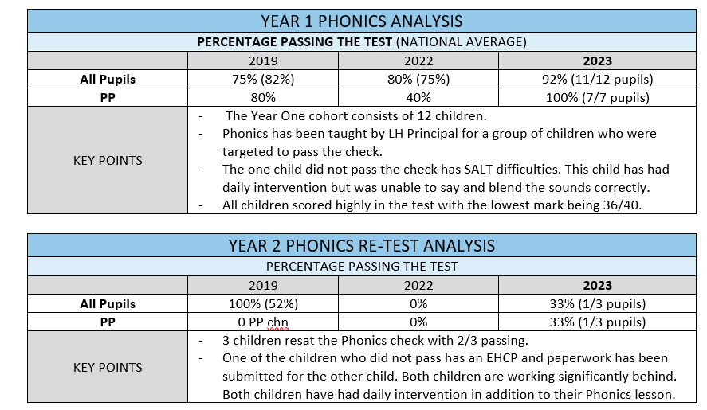
A particular year groups of concern was Y2 (25% pupil premium at expected/greater depth vs 70% of non-pupil premium children) and Y6 (57% PP at expected vs 67% non). We used funding on CPD to support our whole school writing structure and delivery to maximise outcomes for children, we also used conferencing to support our children with the editing process. At the end of the academic year, in Y2 in writing 50% of PP reached expected in writing with 17% achieving greater depth. In Y6 71% of PP achieved expected with 7% achieving greater depth
Challenge 2 Reading
At the start of the academic year particular year groups of concern were Y2 and current Y3. We focused on use of CPD around the teaching of reading and also implemented the intervention reading rocketeers. The intervention was used for Y3/4/5 children who were making limited progress. Following the intervention, 80% of the PP children attending were on track to meet end of year targets. In Y3 progress is being made to close the gap as 10% more PP children are now at age related expectations than at the end of the previous academic year although work still needs to continue to close the gap further. Reading At the start of the academic year particular year groups of concern were Y2 and current Y3
Reading will remain a focus to work on using tuition to target key children, we will also work on CPD around the teaching of reading and use of daily reading time.

Challenge 3 Maths
In Maths, we focused on use of tutoring for Y6 and Y2 children before and after school and also using the school led tutoring funding. Staff received coaching and mentoring on delivering split year group teaching and CPD on how to adapt and deliver the curriculum to accelerate progress.
Additionally, we focused on use of tutoring for Y6 and Y2 children before and after school and also using the school led tutoring funding. 89% of the Y6 pupil premium children attending the tutoring achieved expected in the KS2 SATS and 100% of the Y2 PP pupils attending tutoring achieved expected in the KS1 SATS. 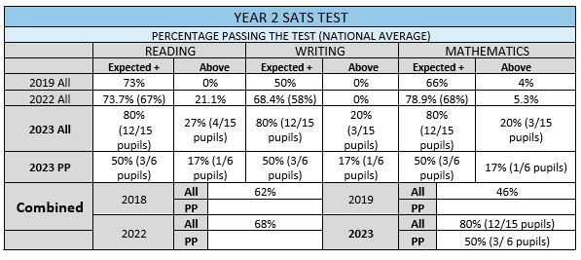

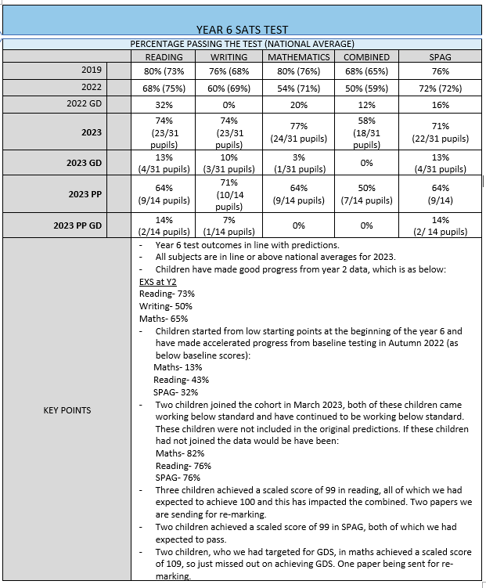
Staff received coaching and mentoring on delivering split year group teaching and CPD on how to adapt and deliver the curriculum to accelerate progress. In Y3 10% more PP children are working at age related and a 7% increase of PP children achieving age related in Y5.
Maths will remain a focus with funding being used to allow for straight year group teaching of maths in the academic year and further CPD around the introduction of same day catch up interventions and arithmetic starters and a weekly test. We will also continue to deliver tutoring for target children.
Challenge 4 Curriculum Engagement
Funding was used to ensure our Pupil Premium children were able to access a variety of clubs to support their interpersonal and team work skills. 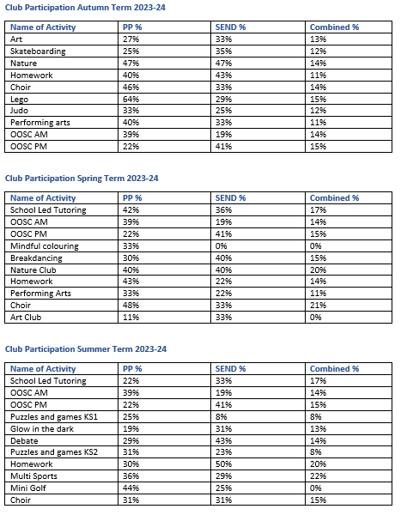
Challenge 5 Behaviour and Mental Health
Throughout the academic year we continued to enhance our nurture support and wellbeing provision through the support of our Senior Learning Mentor and Calderdale MHST. In the EHNA 74% of children surveyed classed their mental health and wellbeing as the top category of thriving.
Previously, poor behaviour had impacted on the academic progress of the children. Our behaviour survey completed showed that 100% of the children understand the new behaviour systems which had been introduced, 86% of children now feel there are consequences for bad behaviour and 86% of children would rate behaviour a 4 or 5 out of 5 – no one rated behaviour any lower than 3 compared to previously when some children would rate behaviour as a 1 or 2. During our pupil voice behaviour survey in February 100% of the children said the children in their class behaved well 100% of children felt that children with protected characteristics are treated the same as everyone else, 100% of the children could identify what constitutes bullying and 100% of the children enjoy lunch and playtimes. A staff survey conducted in February on behaviour showed that 100% of staff felt that behaviour has improved since last year, 100% of staff felt behaviour is good or outstanding. 100% of staff felt behavioural incidents were dealt with effectively in line with the school’s behavioural policy, 100% felt that behaviour had also improved at break and lunchtimes
Challenge 6 Parental Engagement
A lack of engagement from some of our disadvantaged families was identified in regards to supporting home learning and accessing our online learning platform. 47% of our PP families were not accessing our online communication system at the start of the year. We worked with families to offer workshops to support their use of this and it has now been reduced to 21%. It has been identified that the 21% are often families who may struggle with data usage and so paper copies are offered for these target families. We have delivered a homework club throughout the year to support our disadvantaged pupils with completing their home learning. 40% of the club’s attendees have been pupil premium children.
Challenge 7 Attendance
At the start of the academic year 36% of our persistent absentees were pupil premium. Much work was done to track and monitor then intervene which has led to a reduction of 11%. Systems to track attendance are much more robust and good attendance is celebrated.
Additional challenges occurring in year :SEND
SEND across the school has steadily increased throughout the academic year 22-23 from 19% to 29% due to improved identification and improved access to external services. It has been identified that 44% of our pupil premium children are also SEND which has impacted our pupil premium spend. Funding has been used on staff CPD to identify and target SEND learners and the use of the educational psychologist to support identification and target setting. Our tracking and assessment systems needed to be enhanced further, with a more effective way of tracking progress as well as attainment. The purchase of a new assessment system and tracking system allowed us to accurately identify where many of our SEND learners were working in order to identify and address key gaps. We were then able to deliver targeted interventions to focus on closing the gaps – see running log at the bottom of the document for further information. The assessment tool has also enabled subject leaders to be able to track progress and attainment for all pupils and identify gaps more easily.

Externally provided programmes
Please include the names of any non-DfE programmes that you purchased in the previous academic year. This will help the Department for Education identify which ones are popular in England
Programme | Provider
Nuffield Early Language Intervention (Neli) | Elkhan - OUP

Date | Actions and activities | How? What Impact Measures can you report? | Lessons learned | Next steps
Sept | Attendance meetings arranged monthly to identify at risk students (inc PP)  Organisation of extracurricular clubs –wide range of activities.  Behaviour training for all staff on new behaviour system and policy. Assembly for all children on school rules and behaviour | 29% of persistent absentees are PP 1% attendance gap between PP and Non PP  14% of PP children attending clubs  Pupil voice 86% Pupils are happy with the behaviour in our school  100% Pupils understand the new behaviour systems.  100% Pupils know what happens first on the behaviour system | How else can we target those with low attendance?  Increase sporting opportunities  Ensure all staff are following the behaviour system consistently | Attendance monopoly, look at processes for attendance, first letter etc, meet monthly to review attendance.  Look at additional sports based clubs for after half term.  Follow up staff meetings for feedback from staff on how they are finding the behaviour system.
Oct | Attendance meetings arranged monthly to identify at risk students (inc PP)  SEND training on use of Edukey and target setting | Gap between PP has increased to 2%  36% of persistent absentees are PP (increase of 7%)  SMART target setting and use of monitoring to check these | EB to create walking bus with 2 x PP children with persistent lates who are now becoming persistent absentees.  CA to monitor interventions and offer guidance on this and intervention analysis and quality assurance. | Letters to be sent out to parents and EWO contacted.  Information given to staff on baselining to show progress from intervention. Intervention analysis for Autumn.
Nov | Attendance meetings arranged monthly to identify at risk students (inc PP) Walking bus to support 2 PP children | Decrease of 9% of persistent absentees of PP  Overall PP attendance remains the same.  . | Trial target children now with walking to school independently on their own. | Monitor attendance referral for early help if necessary.
Dec | School led tutoring organised and set up for after the half term.  Ongoing throughout Autumn term Maths lead to teach Y2 maths to help close the gap between PP and Non PP  PP lead identified links between SEND and PP.  Parental engagement for PP parents through seesaw was low. With 47% of PP parents not accessing seesaw  Attendance meetings arranged monthly to identify at risk students (inc PP) | NFER Autumn scores to be compared with those at the end of Spring and raw and scaled scores for Y2 and Y6 from Autumn to be compared with those at the end of Spring.  82% of children are now scoring over 50% in their arithmetic vs 22% at the start of the term with 75% of children on track for age related. 66% of PP children within the group on track for age related.  Analysis of Autumn data to identify those who are PP and not on track for age related and the links between PP and SEND.  LSWM offering workshops for PP parents to show how to access seesaw. Target invites for those families not accessing.  3% difference between PP and non PP.  Increase of 3% PP (following stopping of the walking bus) | Difficulties sourcing the tutor in the Autumn term. It would have been preferable to have commenced tutoring earlier however we now have a clear idea of gaps and the focus for the tutoring.  Children are still finding reasoning questions tricky. 33% of PP accessing maths lead teaching still not on track  In all year groups from Y2 and upwards of those pupil premium children who are making not on track to reach age related at least 40% + are pupil premium and SEND (this figure is greater in certain year groups and subjects)  Some PP parents struggle with data to access information on line. Key families will also need paper copies of letters  Referral for key families of persistent absentees to early help completed | Drop ins on tutor for quality assurance, feedback and then comparison of Autumn and Spring data.  T to incorporate reasoning questions into starters. 33% of PP not on track to access tutoring x 3 weekly.  Staff training in January on adaptations/ differentiation for the curriculum for SEND learners. Followed up by SEND learning walk to identify areas of strengths and areas for development  Paper copies of key information to be sent out to parents – additional drop ins for those still struggling.  Inviting parents and children in to celebrate week’s attendance.
January | Interventions analysis and intervention observations  SEND walk round  PP children who have not yet accessed clubs. | Touch typing 75% improvement in speed  75% able to read all sounds from GPC correctly.  100% spellings doubled from initial baseline  100% handwriting improvements.  46% of pupils from Maths intervention Y6 now working at ARE.  CA drop ins to check adaptations are being put in place from January INSET  Observations of interventions to assess effectiveness  Parents of PP children not accessing clubs to be targeted for Spring 2 | Maths tutoring for Y6 needing more sessions for impact, EEF research showing interventions (2-5 times per week)  Feedback given to staff and support around implementing adaptations into planning.  Identified weaker interventions and opportunities for development incorporated.  KS2 and KS1 club at the same time. | Increase of tutoring to x 3 weekly (inc 2 mornings)  Book look and correlation to this support during typicality.  Spring analysis of data linked to interventions
February | Reading Rocketeers intervention launched | 80% of the pupils who attended the intervention are now on track in reading | Intervention to continue and focus on others who are making limited progress | Use of reading lead to start up a reading club in Summer 2
March | Y6 maths tutoring has been ongoing since January | 57% of PP children are on track for age related (impacted by 2 PP children who have moved into the cohort working well below ARE) | 100% of PP children who are not achieving ARE in maths are also SEN support. | Ongoing use of vice principal to target PP children who are at risk of not achieving ARE.
April | Educational psychologist has observed 3 children  Spring Interventions to target gaps | EHCP submissions being written ready for Summer 1 submission.  Touch Typing Y4/5 75% typing had improved in speed by the end of the 6 weeks  Phonics GPC Y1/2 50% of children were able to recognize all of the initial phonemes they found difficult at baseline.  50% were able to recognize over 60% of the phonemes correctly.  Phonics GPC Rec 16% could recognize all the initial phonemes from baseline, 32% could recognize 88% of the phonemes they found difficult at baseline. 16% could recognize 50% of the phonemes baselined on, 16% could recognize 60% of the phonemes.  Phonics Oral Blending Rec  25% were able to blend all of the initial words they found difficult at baseline. 75 % were able to blend 89% of the initial words.  SPAG Y6  100% of children are now at expected whereas at baseline 50% of children were at expected. Of those children who were expected at the start of the intervention they have increased their scaled score and raw scores.  Maths Boost 1:4 (after school) JV 50% of those attending now achieving ARE vs 0% at baseline.  Maths Boost 1:4 CA (after school) 100% of children are now ARE vs 0% of the children at the start of the intervention.  Maths Boost 1:5 (after school) AB 100% of children are now working at ARE vs 50% at baseline.  Private tutor GDS group 1:6 16% are now working at GDS vs 100% who were working at ARE at baseline.  Precision Teaching multiplication tables  Y4 (18 chn) 67% of pupils have improved their baseline scores on the TT rockstar soundcheck. 94% of the children started on a score less than 21. 30% have now increased their scores to be 21 or above out of 25 from an initial starting point below 20. | Early identification of SEND is key to try to get the support in place. | Accurate identification of SEND.  Interventions found to be having an impact to continue.
May | Pupil premium attendance  10% gap between persistent absent PP and non PP  3% gap between PP and Non PP attendance | Increase of EWO involvement for key families | Continued use of attendance meetings to target persistent absence and continued use of EWO. | Attendance meetings to continue to ensure robust tracking of absences.
June | Training on mixed age group curriculum. | LH and CA attended training on mixed year group curriculum planning – curriculum planned for 2023-24 | Progression grids to be completed for 23-24 to link with subjects. | Pupil voice for planning.

