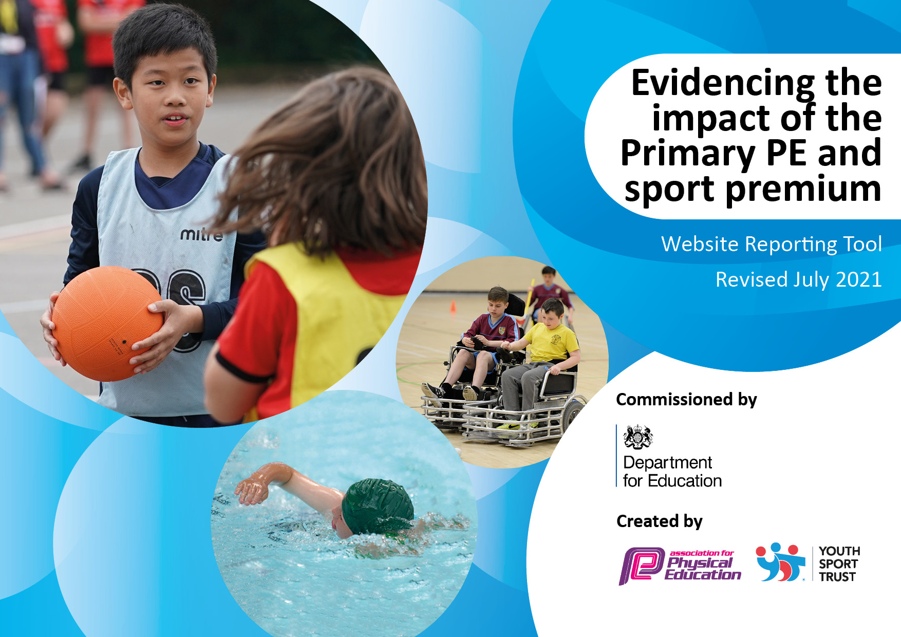
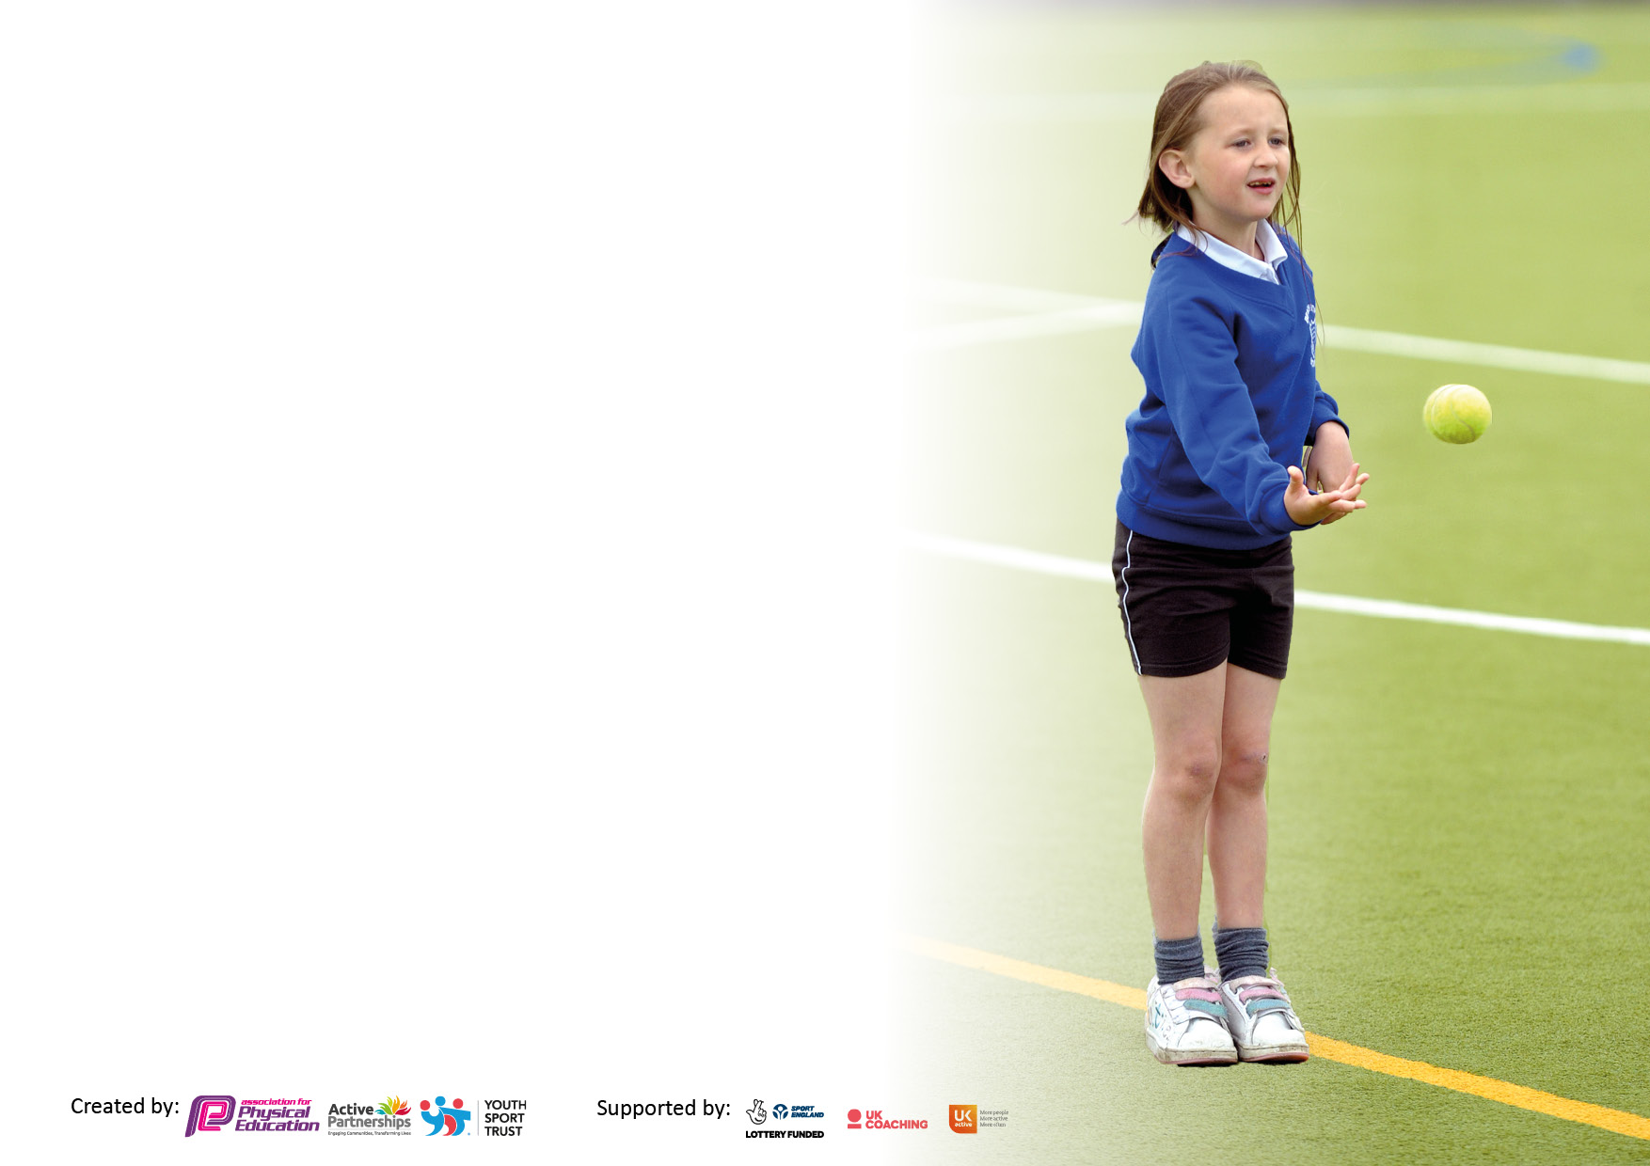

It is important that your grant is used effectively and based on school need. The Education Inspection Framework makes clear there will be a focus on ‘whether leaders and those responsible for governors all understand their respective roles and perform these in a way that enhances the effectiveness of the school’.

Under the Quality of Education Ofsted inspectors consider:
Intent - Curriculum design, coverage and appropriateness
Implementation - Curriculum delivery, Teaching (pedagogy) and Assessment
Impact - Attainment and progress

To assist schools with common transferable language this template has been developed to utilise the same three headings which should make your plans easily transferable between working documents.

Schools must use the funding to make additional and sustainable improvements to the quality of Physical Education, School Sport and Physical Activity (PESSPA) they offer. This means that you should use the Primary PE and sport premium to:

- Develop or add to the PESSPA activities that your school already offer
- Build capacity and capability within the school to ensure that improvements made now will benefit pupils joining the school in future years
- The Primary PE and sport premium should not be used to fund capital spend projects; the school’s budget should fund these.

Pleasevisitgov.ukfortherevisedDfEguidanceincludingthe5keyindicatorsacrosswhichschoolsshoulddemonstrate animprovement.Thisdocumentwillhelpyoutoreviewyourprovisionandtoreportyourspend.DfEencouragesschools to use this template as an effective way of meeting the reporting requirements of the Primary PE and sport premium.

We recommend you start by reflecting on the impact of current provision and reviewing the previous spend.

Schools are required to publish details of how they spend this funding, including any under-spend from 2019/2020, as well as on the impact it has on pupils’ PE and sport participation and attainment. All funding must be spent by 31st July 2022.

We recommend regularly updating the table and publishing it on your website throughout the year. This evidences your ongoing self-evaluation of how you are using the funding to secure maximum, sustainable impact. Final copy must be posted on your website by the end of the academic year and no later than the 31st July 2021. To see an example of how to complete the table please click HERE.
Created by: Supported by:

Details with regard to funding
Please complete the table below.

Total amount carried over from 2021/22 | £0
Total amount allocated for 2021/22 | £0
How much (if any) do you intend to carry over from this total fund into 2022/23? | £0
Total amount allocated for 2022/23 | £17,300
Total amount of funding for 2022/23. To be spent and reported on by 31st July 2023. | £17,300
Swimming Data
Please report on your Swimming Data below.

Meeting national curriculum requirements for swimming and water safety.

N.B. Complete this section to your best ability. For example you might have practised safe self-rescue techniques on dry land which you can then transfer to the pool when school swimming restarts.
Due to exceptional circumstances priority should be given to ensuring that pupils can perform safe self rescue even if they do not fully meet the first two requirements of the NC programme of study
What percentage of your current Year 6 cohort swim competently, confidently and proficiently over a distance of at least 25 metres?  N.B. Even though your pupils may swim in another year please report on their attainment on leaving primary school at the end of the summer term 2021.  Please see note above | 10%
What percentage of your current Year 6 cohort use a range of strokes effectively [for example, front crawl, backstroke and breaststroke]?  Please see note above | 10%
What percentage of your current Year 6 cohort perform safe self-rescue in different water-based situations? | 10%
Schools can choose to use the Primary PE and sport premium to provide additional provision for swimming but this must be for activity over and above the national curriculum requirements. Have you used it in this way? | No

Action Plan and Budget Tracking
Capture your intended annual spend against the 5 key indicators. Clarify the success criteria and evidence of impact that you intend to measure to evaluate for pupils today and for the future.

Academic Year: 2022/23 | Total fund allocated: £17,300 | Date Updated: July 23
Key indicator 1: The engagement of all pupils in regular physical activity – Chief Medical Officers guidelines recommend that primary school pupils undertake at least 30 minutes of physical activity a day in school |  |  |  | Percentage of total allocation:
 |  |  |  | 61%
Intent | Implementation |  | Impact
Your school focus should be clear what you want the pupils to know and be able to do and about  what they need to learn and to  consolidate through practice: | Make sure your actions to achieve are linked to your intentions: | Funding allocated: | Evidence of impact: what do pupils now know and what can they now do? What has changed?: | Sustainability and suggested next steps:
Improve the physical activity levels in our most inactive pupils.  Children to be more active physically at lunchtimes and break times  Improve the physical activity levels in our EYFS pupils whilst providing more opportunities for gross motor development  Ks1- whole class physical activity in class morning / afternoon with movement time to increase the time the children are physically active. Greater opportunity for some children to meet ‘Active 60.’ | Introduction of new specialist provider to support staff  CPD and to increase provision, resourcing and enjoyment  by children  • Specialist clubs e.g. sports, karate, table tennis, dance  • Engage pupils not meeting the CMO guidelines through  targeted active play during active breaks, breaktime,  lunchtime & clubs.  New markings on the concrete to help zone the playground into particular activity areas.  New PE scheme to support coverage and progression of skills  Replenish equipment for EYFS children to have access to high quality resources for outdoor activities linked to physical activity and gross motor skills.  Teachers are given access to many different physical activity websites which are classroom based and will ensure that all children partake in an extra 10 minutes of physical activity at least twice a week to support physical and mental wellbeing. Time can be used straight after morning work and straight after lunch time. | £5984  £1,971  £695  £1970  £0 | Sports cool have been leading clubs and the children have been enjoying these sessions and the staff are being upskilled. A KS1 multi sports club has been offered, an archery club and a lunchtime girls football club has been offered and has been popular. All clubs have a good up take and the children are enjoying them. In Summer 2 a glow in the dark sports club has been delivered and a golf club – again with good pupil numbers. The REAL PE scheme has been purchased to help improve consistency for the teaching of PE across the school, this has been evidenced through floor books.  New playground markings have been completed, the children have enjoyed using them to create their own games. The markings have helped to split the playground into zones – calm zone, quiet zone, sports zone etc.  Sports cool have worked with teachers to focus on how to incorporate physical activities into the children’s days. | New sports leader employed by the trust to support teacher skills and ensure 2 hours of PE sessions a week for children.  Use of REAL PE scheme moving forwards.  Sports Cool Clubs :  Glow in the dark (16) All spaces filled  19% (PP)  31% (SEND) 13% (Combined)  Multi Sport (14) 2 spaces free 36% (PP) 29% (SEND)22% (Combined)  Mini Golf (16)  All spaces filled 44% (PP)25% (SEND) 0% (Combined)  In the EHNA survey pupils were asked on how many days they were physically active for a total of 60 minutes per day, over the past week.  The most common response was '7 days' (45%). They were also asked how often they get out of breath or sweat due to exercising in their free time, and said 'More than 3 times a week' (50%).
Key indicator 2: The profile of PESSPA being raised across the school as a tool for whole school improvement |  |  |  | Percentage of total allocation:
 |  |  |  | 12%
Intent | Implementation |  | Impact
Your school focus should be clear what you want the pupils to know and be able to do and about  what they need to learn and to  consolidate through practice: | Make sure your actions to achieve are linked to your intentions: | Funding allocated: | Evidence of impact: what do pupils now know and what can they now do? What has changed?: | Sustainability and suggested next steps:
Children will be more actively engaged in physical activity at playtimes and lunchtimes. | Replenish equipment for children to have access to high quality resources during playtimes and lunchtimes. | £1,000 | Equipment has been replenished and the children have been enjoying using the new equipment. MDS staff have been delivering key activities in different areas of the playground on a rota to offer the children a variety of different activities. New storage equipment has been purchased to store all the PE equipment. The children are more engaged and active at playtimes and have reported an improvement in behaviour. | CPD provided for MDS on new equipment. MDS meetings to ensure all MDS know what equipment is available and to ensure a variety of equipment is out for the children.
To train up new Year 5 children to become Phunky Foods ambassadors. | Phunky foods activities such as physical activities which can be used in the class (to comply with Covid guidance around smaller groups for indoor PE ) and mental wellbeing activities are known to staff and all staff are able to login to access these resources when necessary. | £0 | Phunky foods have continued their work with the Y5 ambassadors and they recently delivered a competition amongst their peers focusing on how many skips they could do in a minute etc – the children really enjoyed this and it raised the profile of different activities that the children could do to keep fit. The ambassadors also led a keep fit assembly for the whole school to help them understand how to keep themselves fit and healthy. | Phunky foods to continue with next year’s Year 5s. 87% of the children at our school would list their health as excellent or good in the recent education needs health assessment survey which is 3% higher than the average for other Calderdale schools.
Develop the children’s skills, confidence and road safety with cycling. | Bikeability to offer level 1 to Y4/5 and to run level 2 session for both Y6 classes and balance bikes session for reception and Y1/2 | £0 | Bikeability sessions have taken place for Y4/5 and R, Y1/2 and Y6. The children enjoyed the sessions and were keen to discuss the new skills they have learnt. | Bikability sessions to be booked in again for the new academic year.  32 R/Y1/2 children took part in the balance bike sessions.  30 children out of Y4/5 took part and 32 children in Y6 took part.  100% of children who participated in Level 1 passed.  92% of children passed level 2

Key indicator 3: Increased confidence, knowledge and skills of all staff in teaching PE and sport |  |  |  | Percentage of total allocation:
 |  |  |  | 27%
Intent | Implementation |  | Impact
Your school focus should be clear | Make sure your actions to | Funding | Evidence of impact: what do | Sustainability and suggested
what you want the pupils to know | achieve are linked to your | allocated: | pupils now know and what | next steps:
and be able to do and about | intentions: |  | can they now do? What has
what they need to learn and to |  |  | changed?:
consolidate through practice:
To upskill staff in understanding how to use an outdoors curriculum to promote physical activity and skills. | Children to access forest school through Chameleon outdoor activities – staff supported on being upskilled with this. | £4,680 | Y3/4 have been taking part in a weekly session of forest schools where they have worked on many different skills. The children have enjoyed these sessions and taking part. Year 6 also completed forest school sessions in Summer 2. The children developed their interpersonal, team work and listening skills.  Children developed weaving and happazome printing skills using natural resources. They have developed a safe use of the basic forest school tools axe, saw, secateurs and vegetable peeler. Fire making skills ferrous rod, flint and steel and fire by friction to produce hot water. Knot and hitch skills. | Y2/3 to commence forest school sessions in the new academic year.
Improve the outdoor provision that is provided for children at West Vale. Children to develop key skills in an outdoor environment. | All children from Year 1 to Year 6 over the year will benefit from 2 hour weekly sessions for a 6 week block. | £0 | All children have an indoor and an outdoor PE session weekly. The outdoor session is supported by sports cool to work on upskilling the staff.  The children have worked on sending and receiving skills, balancing and travelling and ball control skills. The children have covered gymnastics –balance and travelling, badminton – serving and rallying and basketball – ball control and shooting. | All children to have two sports sessions in the new year – one led by the sports coach.
Key indicator 4: Broader experience of a range of sports and activities offered to all pupils |  |  |  | Percentage of total allocation:
 |  |  |  | 0%
Intent | Implementation |  | Impact
Your school focus should be clear | Make sure your actions to | Funding | Evidence of impact: what do | Sustainability and suggested
what you want the pupils to know | achieve are linked to your | allocated: | pupils now know and what | next steps:
and be able to do and about | intentions: |  | can they now do? What has
what they need to learn and to |  |  | changed?:
consolidate through practice:
To make other sports available to the children through assemblies, taster sessions, after school clubs and PE lessons. | Additional clubs offered to classes through a half termly teacher led clubs offer. Clubs offered sent to parents out on a half termly basis. | £0 | Morning gymnastics club has been on offer for the Spring term 16 children attending 33% PP and 12% SEND, the children have enjoyed attending this. We have also had archery 16 children attending 26% PP 26% SEND, judo, multi sports and girls football club 20 children 50% PP and 25% SEND on going. | New sports coach to offer a variety of clubs in the new year – judo to continue.

Key indicator 5: Increased participation in competitive sport |  |  |  | Percentage of total allocation:
 |  |  |  | 6%
Intent | Implementation |  | Impact
Your school focus should be clear | Make sure your actions to | Funding | Evidence of impact: what do | Sustainability and suggested
what you want the pupils to know | achieve are linked to your | allocated: | pupils now know and what | next steps:
and be able to do and about | intentions: |  | can they now do? What has
what they need to learn and to |  |  | changed?:
consolidate through practice:
To develop children’s resilience within competitive sports.  To improve the percentage of girls taking part in competitive sports | Specific sports leader to arrange interschool competitive sports activities with a focus on encouraging girls into sport. | £1,000 | Girls football team is currently running, they train once a week during a lunchtime session.  20 girls took part in the football team and played friendly matches against one another in friendly matches. | Use of new sports lead to arrange for the girls football team (plus new members due to Y6 members leaving) to enter competitions for 23-24.

Signed off by
Head Teacher: | L.Horsfall
Date: | 20.07.23
Subject Leader: | R. Taylor
Date: | 20.07.23
Governor:
Date: | 20.07.23

